Course Name | ITD 2343 – Object Oriented Programming with C#
Instructor | Mark L. Pranger
Student Name | Lauren Lashley
Due date | March 15, 2026
Grade | <grade earned here>
Grading Comments | <instructor comments here>
Section 3 - Week 8 to Week 10 Programming Lab
3 Shots of the Build:
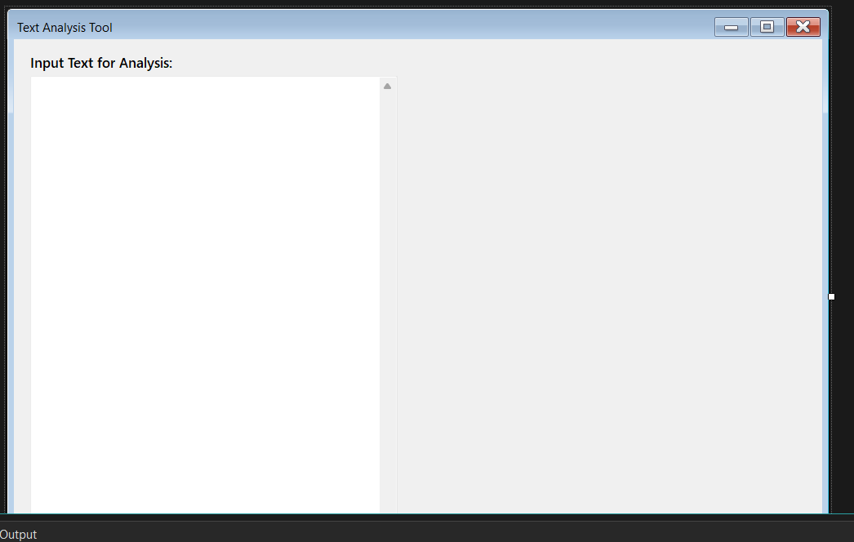
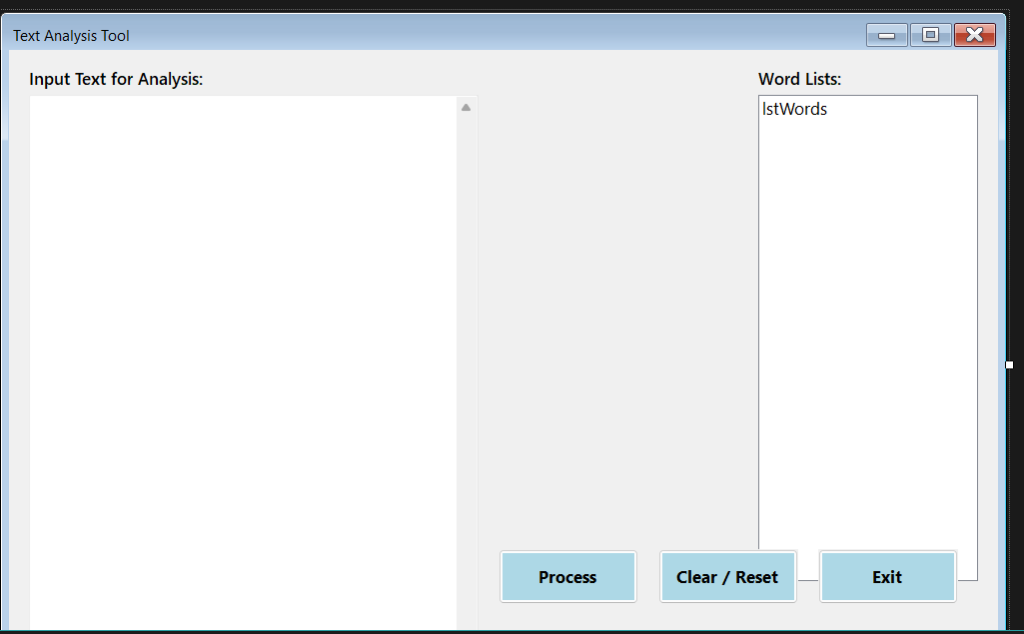
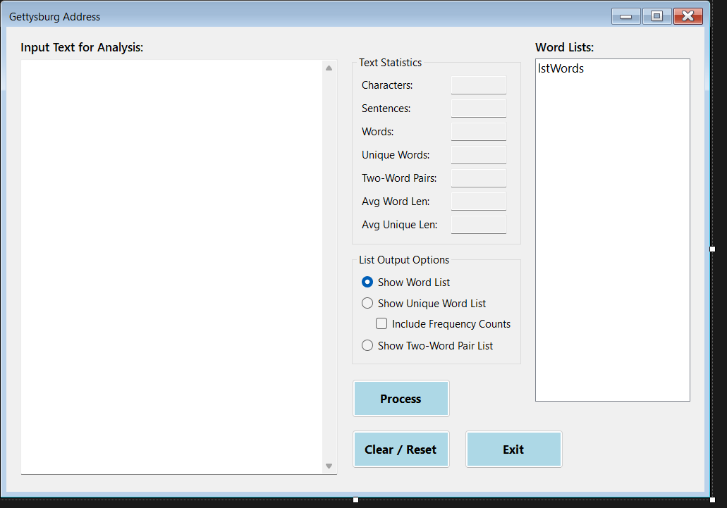

Screen shot showing the Word List:
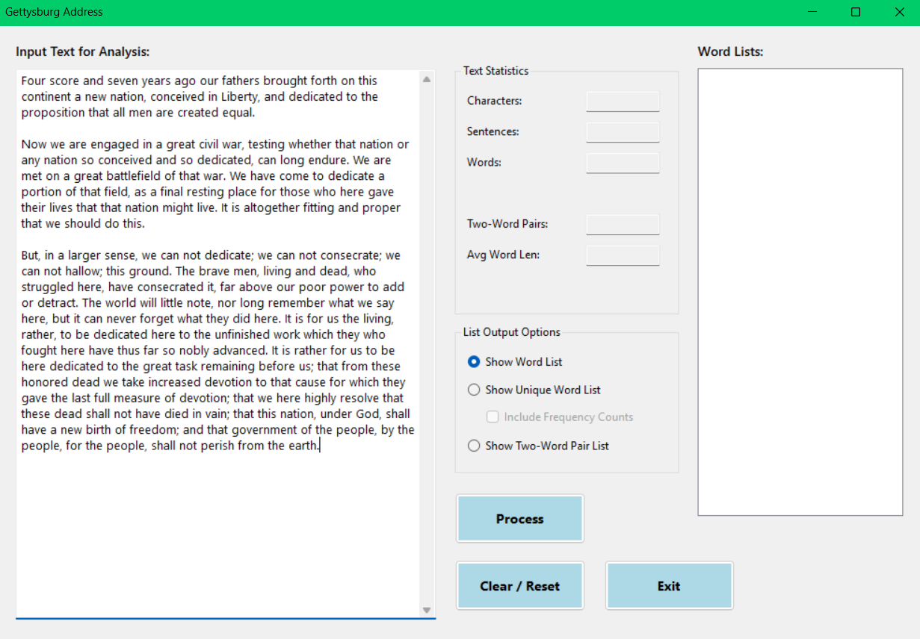

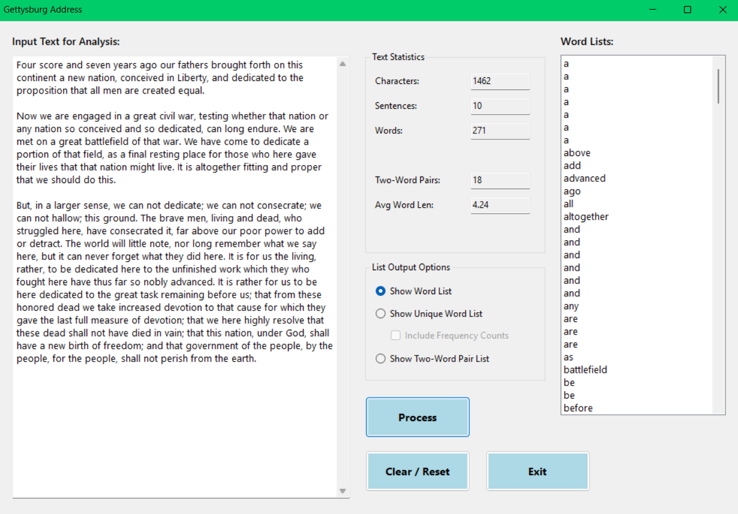

Screen shot showing the Two-Word List:
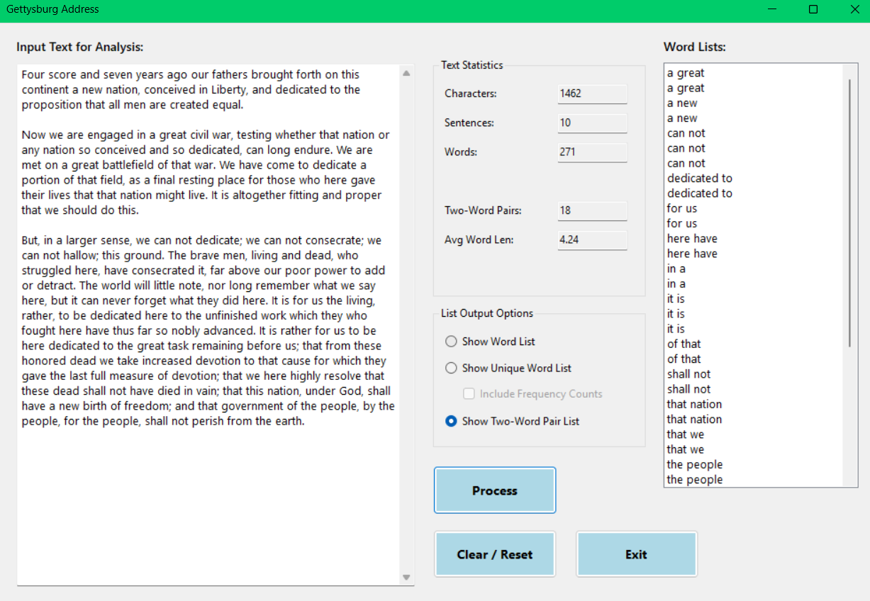

Screen shot showing the Unique turned Off List:


Screen shot showing the Unique turned On List with frequency count turned Off:
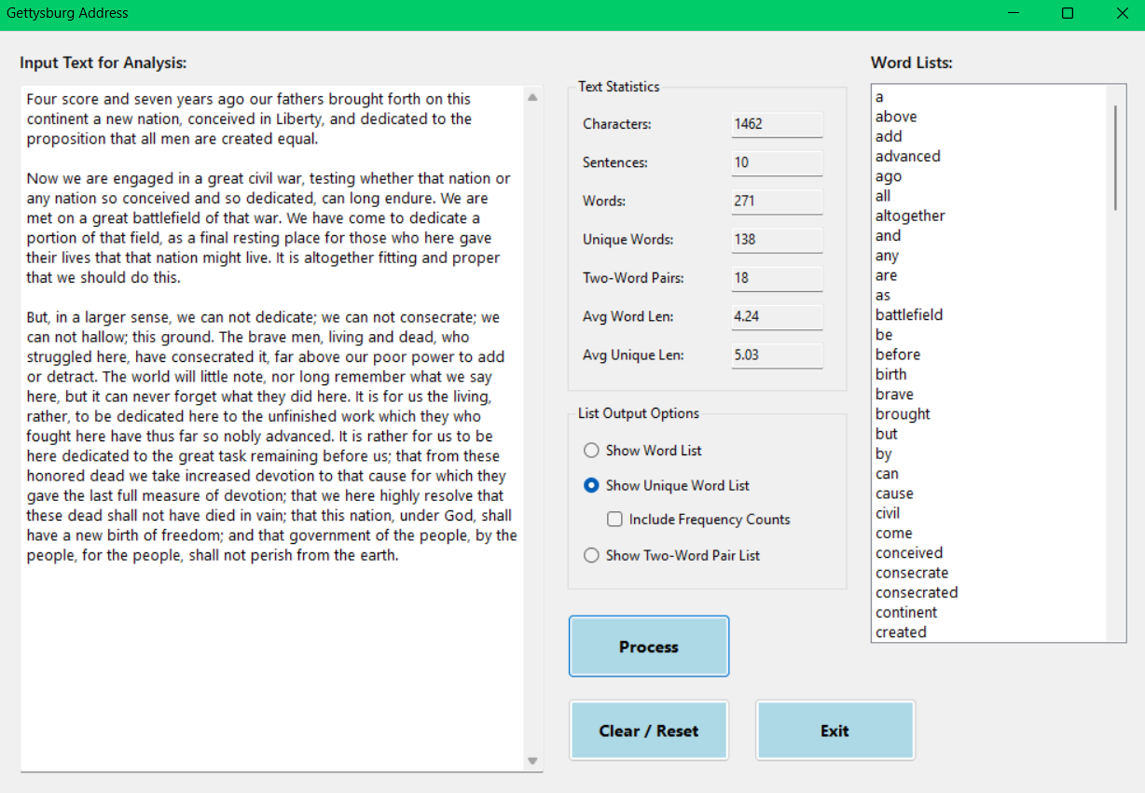
Screen shot showing the Unique turned On List with frequency count turned on:
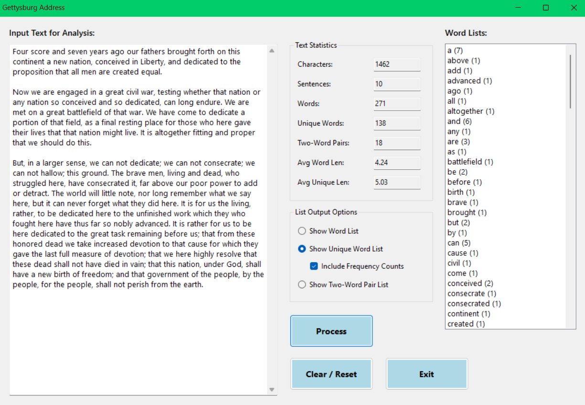

Screen shot showing some Hyphenated Words mixed with non-Hyphenated words:
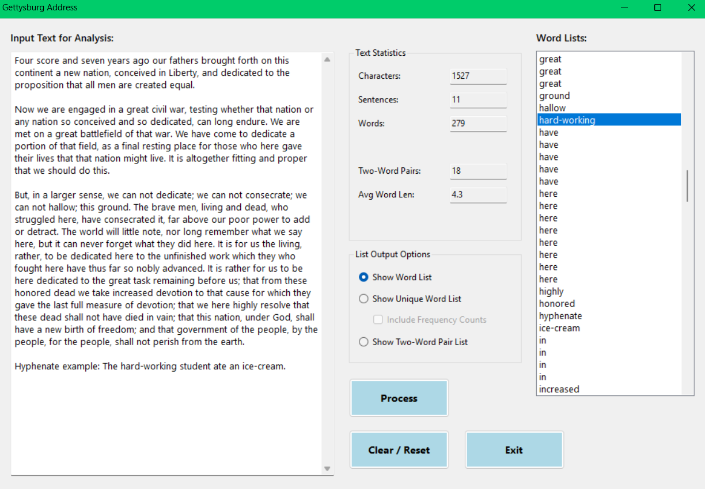
Screen shot showing some Punctuation in the text:
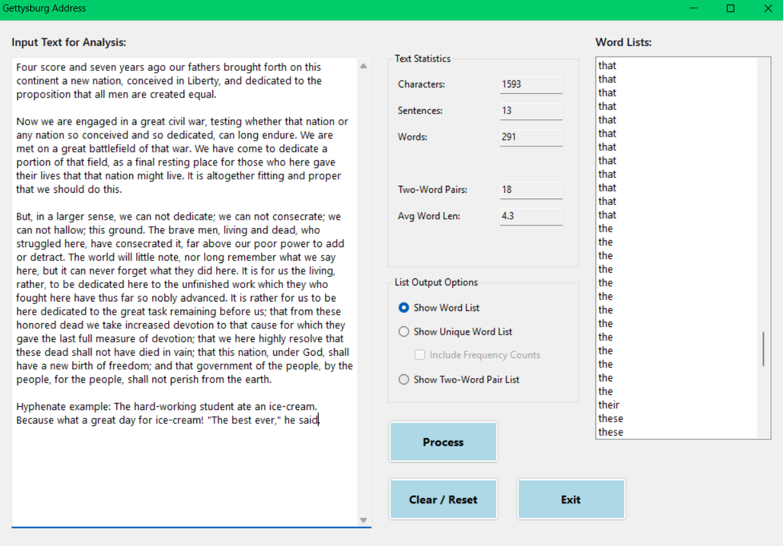

Screen shot showing some Numbers in the text: First sentence changed to show it doesn’t show up
